**CSE-326 project**

***Final Report***

**Railway Reservation System**

***Submitted by:***

***Dikshant sharma (11918272)***

***Rahul bhagat (11917811)***

***Satyam Seth (11905216)***

***Introduction***

***Railway reservation system:***

***Html:***  *Html is used to create webpages in our project and is also used to add links in the webpage. All the tabs and buttons are created using html.*

***CSS:*** *CSS is used for designing the webpages and it is also used for sectioning of webpage and the animations of webpages. All the buttons and form tags and their colors are design through css.*

***Java Script:*** *IT is used for various windows alert and for exchanging button which is between the*

*Form and to tab for interchanging their values.*

***HTML by Rahul***

***CSS by Dikshant***

***Java script by Satyam***

***Feature of project railway reservation system:***

* *Find the train.*
* *Book the meal.*
* *Contact if you have any issue.*
* *Check what service are available at the station.*
* *Check the holiday packages.*

***Objective of the project:***

*The objective of our project is to create an attractive webpage of railway reservation system with several feature like to check service at station, meals slot with the use of html, css and java script and few other languages so the user get an immersive experience when web page open.*

***User interface:***

*We created our project as much simple and user friendly as possible, the colors we used are simply and attractive the functionality of different tabs are attractive and simple.*

***Webpage Images***

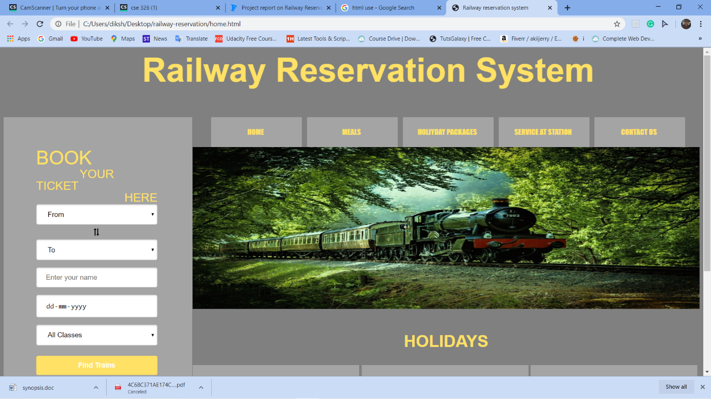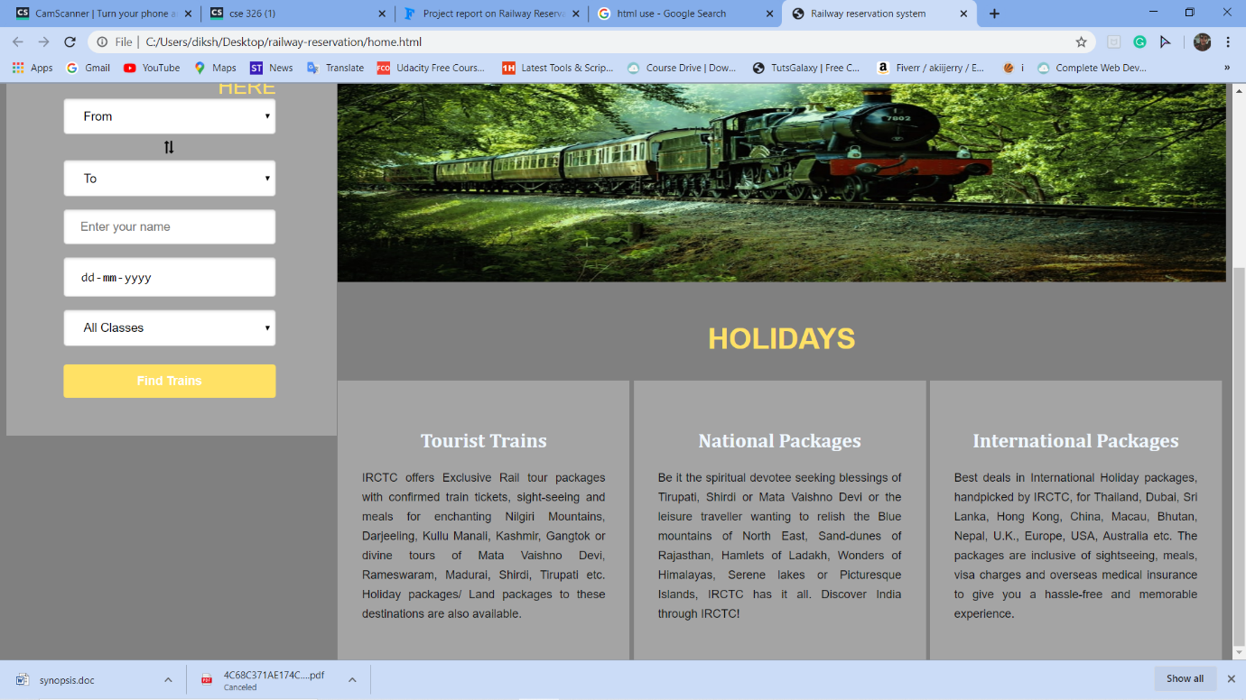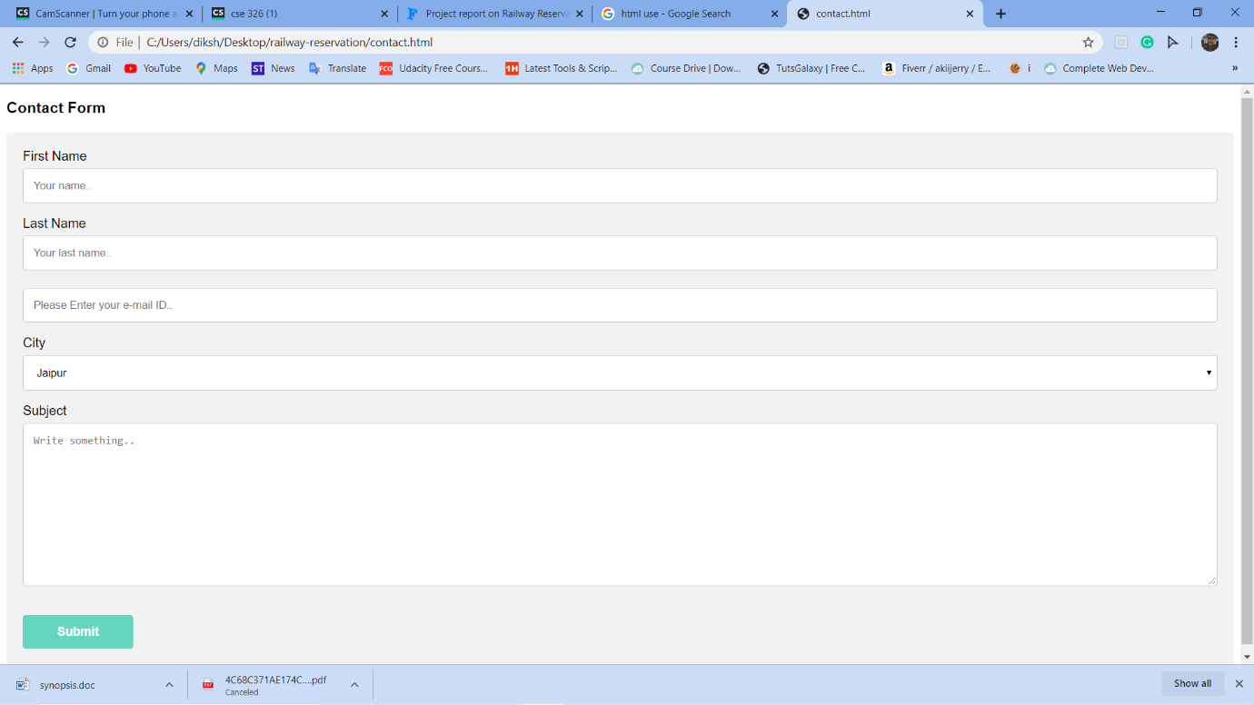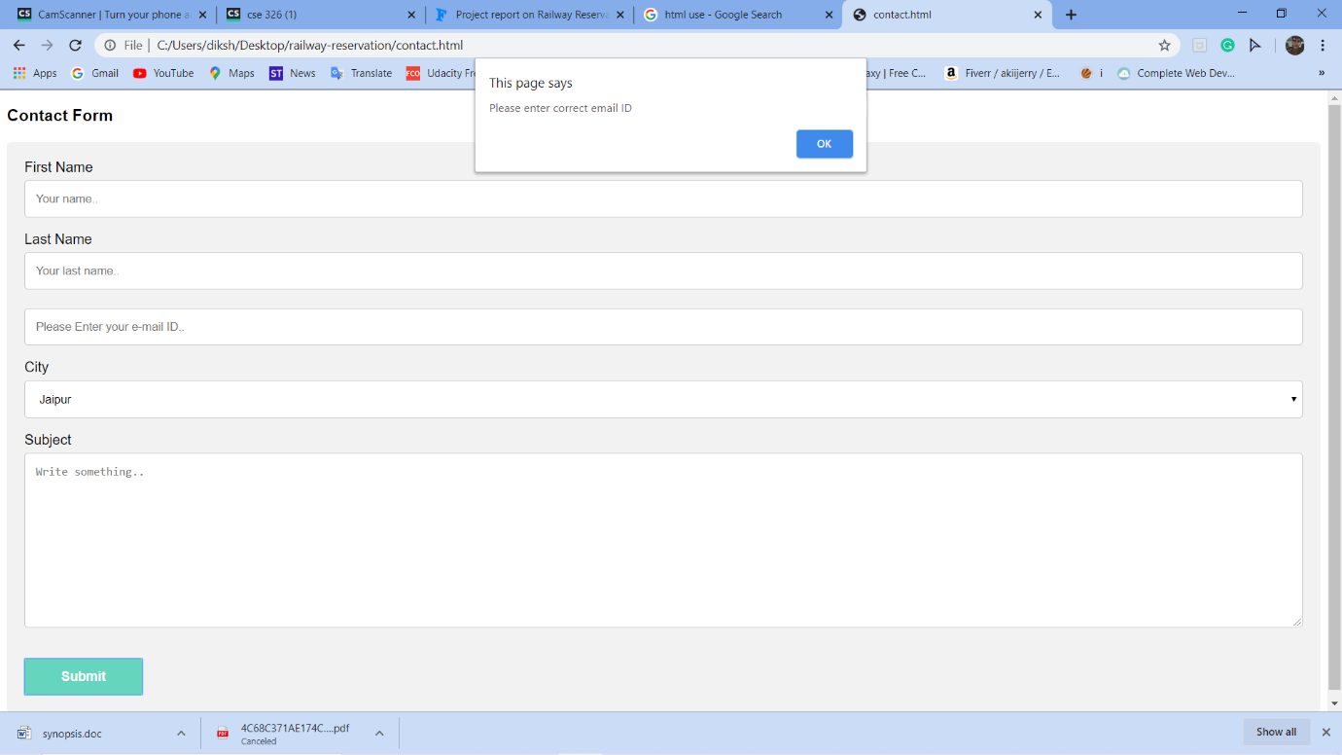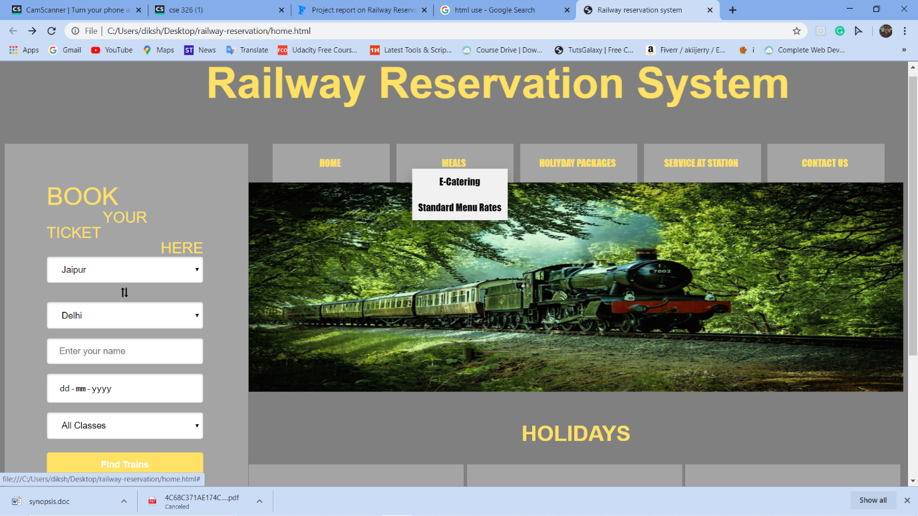

***Programming part***

***<html>***

***<head>***

***<link rel="stylesheet" href="https://cdnjs.cloudflare.com/ajax/libs/font-awesome/4.7.0/css/font-awesome.min.css">***

***<link rel="stylesheet" href="styles.css">***

***<script type="text/javascript" src="swapValue.js"></script>***

***<title>***

***Railway reservation system***

***</title>***

***</head>***

***<body>***

***<font size="45" color="#ffe165">***

***<div class="heading">***

***<h2>***

***<marquee>Railway Reservation System </marquee>***

***</h2>***

***</div>***

***</font>***

***<div class="left-side">***

***<form action="" process.html" method="post" onsubmit="getValues()">***

***<div class="bookingslot">***

***<h2 align="left" class="book-title1">BOOK</h2>***

***<h2 align="center" class="book-title2"> YOUR </h2>***

***<h2 align="left" class="book-title3"> TICKET </h2>***

***<h2 align="right" class="book-title4"> HERE</h2>***

***<ul class="content">***

***<select required="" name="from" onchange="this.form.()" id="d" value="From" required>***

***<option value>From</option>***

***<option value="jaipur">Jaipur</option>***

***<option value="delhi">Delhi</option>***

***<option value="phagwara">Phagwara</option>***

***<option value="mumbai">Mumbai</option>***

***<option value="jalandhar">Jalandhar</option>***

***<option value="amritsar">Amritsar</option>***

***<option value="Ahemdabad">Ahemdabad</option>***

***<option value="surat">Surat</option>***

***<option value="jammu">Jammu</option>***

***<option value="chandigarh">Chandigarh</option>***

***</select>***

***<br>***

***<a id="go" onclick="swapValues()"> <i class="fa fa-exchange rotate90"></i></a>***

***<br>***

***<select required name="from" onchange="this.form.()" id="c">***

***<option value="">To</option>***

***<option value="jaipur">Jaipur</option>***

***<option value="delhi">Delhi</option>***

***<option value="phagwara">Phagwara</option>***

***<option value="mumbai">Mumbai</option>***

***<option value="jalandhar">Jalandhar</option>***

***<option value="amritsar">Amritsar</option>***

***<option value="Ahemdabad">Ahemdabad</option>***

***<option value="surat">Surat</option>***

***<option value="jammu">Jammu</option>***

***<option value="chandigarh">Chandigarh</option>***

***</select>***

***<br>***

***<input type="text" name="name" placeholder="Enter your name" required><br>***

***<input type="date" required><br>***

***<select name="select1" size="1" required>***

***<option value="All Classes">All Classes</option>***

***<option value="sanfancisco">Second Class</option>***

***<option value="Jaipur">First-AC class</option>***

***<option value="">Second-AC Class</option>***

***<option value="">Third-AC Class</option>***

***</select>***

***<br>***

***<button type="submit"onClick="function()">Find Trains</button>***

***</ul>***

***</div>***

***</form>***

***</div>***

***<div class="right-side">***

***<ul class="menu-list">***

***<li><a href="home.html" class>HOME</a></li>***

***<li>***

***<!-- <a href="#tuesday" class>MEALS</a> -->***

***<div class="dropdown">***

***<a href="#" class="dropbtn">MEALS</a>***

***<div class="dropdown-content">***

***<a href="#">E-Catering</a>***

***<a href="#">Standard Menu Rates</a>***

***</div>***

***</div>***

***</li>***

***<li>***

***<!-- <a href="#wednesday" class>HOIYDAY PACKAGES</a> -->***

***<div class="dropdown">***

***<a href="#package" class="dropbtn"> HOLIYDAY PACKAGES</a>***

***<div class="dropdown-content">***

***<a href="#">Special Trains</a>***

***<a href="#">Packages</a>***

***</div>***

***</div>***

***</li>***

***<li>***

***<div class="dropdown">***

***<a href="#service-station" class="dropbtn"> SERVICE AT STATION</a>***

***<div class="dropdown-content">***

***<a href="#">Wi-Fi Railway Station</a>***

***<a href="#">Battery Cars</a>***

***<a href="#">E-Wheelchairs</a>***

***<a href="#">Retiring Rooms</a>***

***</div>***

***</div>***

***</li>***

***<li><a href="contact.html" class>CONTACT US</a>***

***</li>***

***</ul>***

***<div class="image">***

***<img height='350px' width='100%'***

***src="train-image.jpg">***

***</div>***

***<div class="holidays-heading">***

***<h2>HOLIDAYS</h2>***

***</div>***

***<div class="holiday-list-item">***

***<h2>Tourist Trains</h2>***

***<P class="paragraph">***

***IRCTC offers Exclusive Rail tour packages with confirmed train tickets, sight-seeing and meals for***

***enchanting Nilgiri Mountains, Darjeeling, Kullu Manali, Kashmir, Gangtok or divine tours of Mata Vaishno***

***Devi, Rameswaram, Madurai, Shirdi, Tirupati etc. Holiday packages/ Land packages to these destinations***

***are also available.***

***</P>***

***</div>***

***<div class="holiday-list-item">***

***<h2>National Packages</h2>***

***<P class="paragraph">***

***Be it the spiritual devotee seeking blessings of Tirupati, Shirdi or Mata Vaishno Devi or the leisure***

***traveller wanting to relish the Blue mountains of North East, Sand-dunes of Rajasthan, Hamlets of***

***Ladakh, Wonders of Himalayas, Serene lakes or Picturesque Islands, IRCTC has it all. Discover India***

***through IRCTC!***

***</P>***

***</div>***

***<div class="holiday-list-item">***

***<h2>International Packages </h2>***

***<P class="paragraph">Best deals in International Holiday packages, handpicked by IRCTC, for Thailand, Dubai,***

***Sri Lanka, Hong Kong, China, Macau, Bhutan, Nepal, U.K., Europe, USA, Australia etc. The packages are***

***inclusive of sightseeing, meals, visa charges and overseas medical insurance to give you a hassle-free***

***and memorable experience.***

***</P>***

***</div>***

***</div>***

***</body>***

***</html>***

